Questions from the Audience: DrEaMing Webinar 10/11/22
Risk factors for Not DrEaMing include PONV, do you think TIVA should be used to promote DrEaMing?
We do not advocate one anaesthetic technique over another to promote DrEaMing, but the identification of risk factors for NOT DrEaMing is key and should be considered when planning an anaesthetic technique. Managing things like PONV, pain temperature control and considering the use of IV fluids etc are all key areas to look at. “All roads end in DrEaMing” and so to improve DrEaMing rates for PQIP or for the CQUIN in is important to look at all factors that can influence this
Top Tip from the audience:
“Provided it is not major GI surgery, I always arrange for the patients to have a cup of tea in recovery at 30 minutes. If it isn’t tolerated, this is a warning that things may not be right (with PONV)”
Are there any strategies people have found particularly helpful to improve DrEaMing?
Research from PQIP has shown some key enablers to DrEaMing as well as Inhibitors. Dr Georgina Singleton, a previous PQIP fellow has spent time interviewing sites about this. She summarised her findings in a previous webinar. The recording and her slides can be found here:
DrEaMing Webinar May 2022 (pqip.org.uk)
The table below summarises staff, organisational and patient factors that facilitate DrEaMing
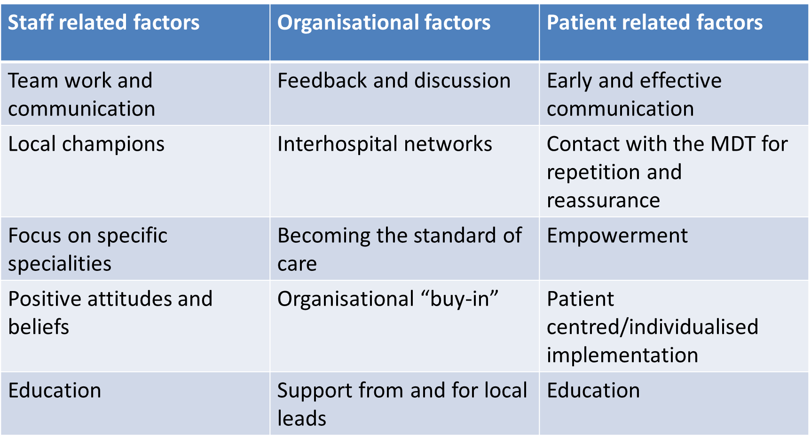
The last PQIP Cohort report also contains some “Top Tips” from sites for QI and DrEaMing, it can be found here: Annual Report 2019 - 21 (pqip.org.uk)
What sample size is adequate to provide evidence for the CQUIN?
Trusts should submit audit numbers from 100 cases. The Getting it Right First Time website has a link to an audit tool that can be used
Drinking, eating and mobilising (DrEaMing) CQUIN – Getting It Right First Time – GIRFT
Why is it important that patients mobilise with only the assistance of one? This could be a reason why patients on ICU are unable to DrEaM?
Although we want as many patients to DrEaM as possible, it is important to remember that it is a QI metric to aid recovery and promote this going forward. It is felt that post-surgery mobilising from bed to chair with one person is an acceptable sign that the patient is beginning their recovery journey at 24 hours. Assistance with more than 1 person could indicate that the patient is not using their own muscles/strength to do this. However, any mobilisation is beneficial and so patients who do not achieve the CQUIN/PQIP targets should still be mobilised where possible. Also, there are recovery benefits from undertaking the constituent parts of DrEaMing separately as discussed by Oliver et al in their recent paper and so even if a patient can’t mobilise, eating and drinking can still be promoted. The link to the paper is here:
DrEaMing Paper: https://authors.elsevier.com/sd/article/S0007-0912(22)00146-5
Why is the DrEaMing time target set at 24 hours post op and not just one day?
When setting a target for QI it needs to be a clear-cut target. 24 hours was chosen to give a clear target that is as prompt as reasonably possible and this is now what the evidence base has been built on.
We have trouble mobilising patients in time due to physio and ward round timings, is this a known challenge?
We can understand that timings can be difficult, you are not alone in this being a challenge. When embarking on DrEaMing QI and the CQUIN, it will be important to engage the whole MDT who will help achieve DrEaMing including physios and clinicians responsible for post op care so the priorities can be set and these challenges worked around. It is also important to remember that not all patients need physio to mobilise and to help the physio workload, it is important to identify patients that may be able to be mobilised by other staff. Doctors, nurses, HCAs can all help as it is everyones responsibility to get people DrEaMing.

Having just taken over as PQIP lead, how do I access my hospital’s data? Are there graphs and trends?
Welcome to PQIP and so glad to have you on board. As PI you should have a log in to the PQIP website. Once logged in, you can access your hospital dashboards to look at your performance under the dashboards tab. Please do not hesitate to get in touch if you have any questions or queries about the dashboards: pqip@rcoa.ac.uk. In addition, you can access your hospital’s site report when logged into the PQIP website under the reports tab.
Practically speaking, how do we evidence DrEaMing? It can be difficult and variable to access this information.
As every Hospital uses different IT systems and different ways to document DrEaMing, we can understand that it might be very easy or very hard to access this information. If your hospital does not have an easy way to find this information, it would be worth considering how to address this when starting a DrEaMing QI project and involve the whole MDT, so all staff who are involved in perioperative care know whether patients can DrEaM and whose responsibility it is to document this, and how.
Top Tips from sites with High DrEaMing rates:
“Prescribe DrEaMing on the post op note and then have a section on post op ward round note to acknowledge if it has been achieved and within the time scale”
“DrEaMing discussed at the surgical sign out and documented, followed up in recovery or on the ward”
“Stickers for the notes to document DrEaMing”
How can I find out if our trust is participating?
To find out if your trust is participating in the DrEaMing CQUIN contact your Clinical Director or your Audit / Research department to find out who is responsible for CQUIN’s at your trust. They should then be able to advise you on this
How much is the financial incentive for the DrEaMing CQUIN? We want to encourage our trust to participate but have found through PQIP alone, it is hard to get things moving forward.
The financial incentive for CQUINS is 1.25% of the hospital providers contract from NHS England. Hospitals are expected to report on all CQUINs applicable to their NHS trust, but need commit to achieving 5. For DrEaMing alone, the financial incentive is 0.25% of the hospital’s budget. This may not sound like a large percentage, but it is a large amount of money. Some hospitals are going to use this to fund half multiple consultant PA sessions to allow time to focus on DrEaMing in their surgical subspecialty.
We do also understand that is can be difficult to instigate QI when hospitals and staff are stretched, but it is worth remembering that patients that DrEaM have fewer complications and a shorter length of stay. This should be an incentive for Trusts because it will help patient flow and surgical efficiency and it improves patient care.
Our last webinar and PQIP cohort reports go into the evidence in more detail and have ideas on how to get the whole perioperative MDT involved.
Is there anywhere on the PQIP website where Trusts share how they are succeeding with DrEaMing? We are keen to engage but are struggling on the ground.
We understand it can be very difficult to get QI “off the ground”. We hope by running these webinars we will be able to continue to share successes and “top tips”. You will receive a summary set of slides from this webinar where we heard how the Thoracic team at UCLH have achieved success and how patients can drive QI. In the last webinar we shared some ideas too, and the link for this is here: DrEaMing Webinar May 2022 (pqip.org.uk)
Sharing ideas is key to QI and so it is worth engaging the whole perioperative MDT to seek ideas and talking to colleagues at other hospitals too.
We also like the idea of sharing ideas on-line and so this is something we will think about introducing in the future.

